# Getting Info About User-Defined Data Types: pg_type Table

Question Screenshot:

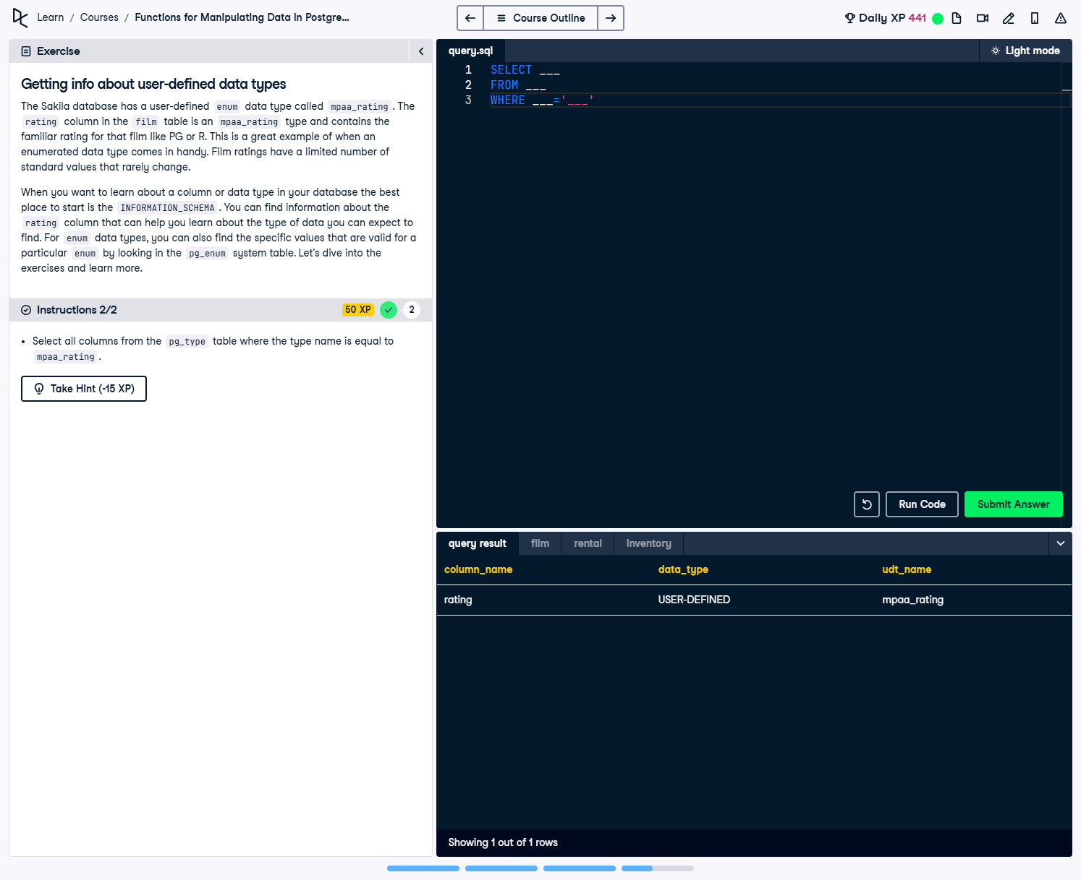

Question:  
The Sakila database has a user-defined ENUM data type called mpaa_rating. The rating column in the film table is an mpaa_rating type and contains the familiar rating for that film like PG or R. This is a great example of when an enumerated data type comes in handy. Film ratings have a limited number of standard values that rarely change.  
  
When you want to learn about a column or data type in your database the best place to start is the INFORMATION_SCHEMA. You can find information about the rating column that can help you learn about the type of data you can expect to find. For ENUM data types, you can also find the specific values that are valid for a particular ENUM by looking in the pg_enum system table.  
  
Instruction:  
1. Select all columns from the pg_type table where the type name is equal to mpaa_rating.

Answer:

-- Select all columns from the pg_type table  
SELECT *  
FROM pg_type  
-- Filter for the ENUM data type called mpaa_rating  
WHERE typname = 'mpaa_rating';

Explanation:

1. SELECT *: Retrieves all columns from the pg_type table to examine detailed information about the data type.  
2. pg_type: A PostgreSQL system catalog table that stores metadata about all data types in the database.  
3. WHERE typname = 'mpaa_rating': Filters the results to show only the ENUM type with the name 'mpaa_rating'.